**Useful article that explains Baseline Model:** <https://www.iguazio.com/glossary/baseline-models/>

1. **Random Forests**

**Rough idea, will come back to elaborate later**

Our baseline model is one that randomly assigns a yoga pose from our dataset. All pose should have an equal chance to be selected since we assume in real user-scenario, all types of yoga pose are equally performed by users.

1. **Support Vector Machine (SVM)**

* Using handcrafted features derived from the human joint coordinates
* Data collection:
  + [COCO](https://cocodataset.org/#home)
  + [MPII Human pose database](http://human-pose.mpi-inf.mpg.de/)
  + [Yoga-82](https://sites.google.com/view/yoga-82/home)

→ The data collection is used as a pre-trained pose estimation model (already done by OpenPose or PoseNet) to extract key joint coordinates from each image or frame.

**→ (Our goal) Calculate handcrafted features from the joint coordinates.**

* **Handcrafted features:**
  + [Pairwise Joint Distances](https://www.sciencedirect.com/science/article/pii/S1877050918309499): Euclidean distances between sets of joints (dist. Between left and right shoulder)
  + [Angles between joints](http://www.clinicalgaitanalysis.com/teach-in/kinematics.html#:~:text=Joint%20angle%20(also%20called%20inter,change%20with%20the%20body%20orientation.): angles formed between sets of joints (shoulder, elbow, etc.)
  + [Relative joint positions:](https://www.researchgate.net/figure/Picture-A-represents-two-joint-repositioning-approaches-First-method-uses-a-reference_fig4_284609749) determine the positions of joints with respect to a reference point (i.e the belly button, the hip)
* **Support Vector Machine (SVM) comes in handy!**
  + **Input:** using vectors derived from handcrafted features
  + **Model:**[Radial Basis Function (RBF)](https://pages.cs.wisc.edu/~matthewb/pages/notes/pdf/svms/RBFKernel.pdf)
  + [**Hyperparameters**](https://www.kaggle.com/code/residentmario/kernels-and-support-vector-machine-regularization)
    - Kernel: RBF
    - Regularization parameter: C/Gamma
  + [**Training & Evaluation**](https://www.v7labs.com/blog/f1-score-guide) **(**accuracy, precision, recall, f1-score)
* **Ethical considerations**
  + Data Collection:
    - Privacy
    - Bias
  + Impacts
    - Health and Safety
    - Misuse
  + Limitations
    - Accuracy and reliability
    - Dependence on data quality

A reasonable baseline model is a Support Vector Machine (SVM) using handcrafted features derived from human joint coordinates. This approach provides a straightforward comparison point for evaluating the performance of more complex neural network models. More particularly, SVMs are suitable due to their ability to handle high-dimensional feature spaces and their effectiveness in binary and multi-class classification tasks. They can create decision boundaries and perform well even with smaller datasets, ensuring reliable pose classification.

**Data Collection and Preprocessing:** We will use a dataset containing images or videos of yoga poses annotated with key joint coordinates, such as COCO, MPII, or Yoga-82. Preprocessing involves using a pre-trained pose estimation model (which has been already done by OpenPose) to extract key joint coordinates from each image or frame, which is one of our main goals.

**Handcrafted features:** The input to the feature engineering process consists of the coordinates of key points for each image or frame. Handcrafted features are derived from these coordinates, including:

* Pairwise joint distances (i.e distance between left shoulder and right shoulder)
* Angles between joints (i.e angle at the elbow formed by the shoulder, elbow, and wrist)
* Relative joint positions (i.e relative position of joints with respect to a reference joint like the center of the body)
* 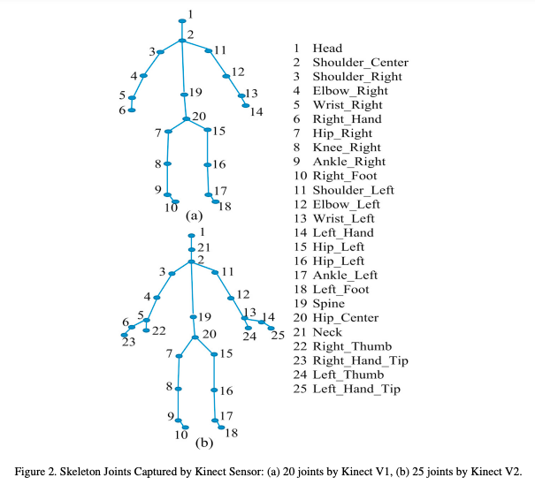
* 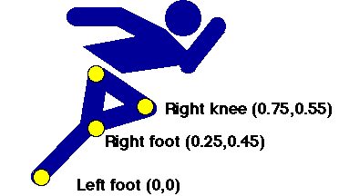
* 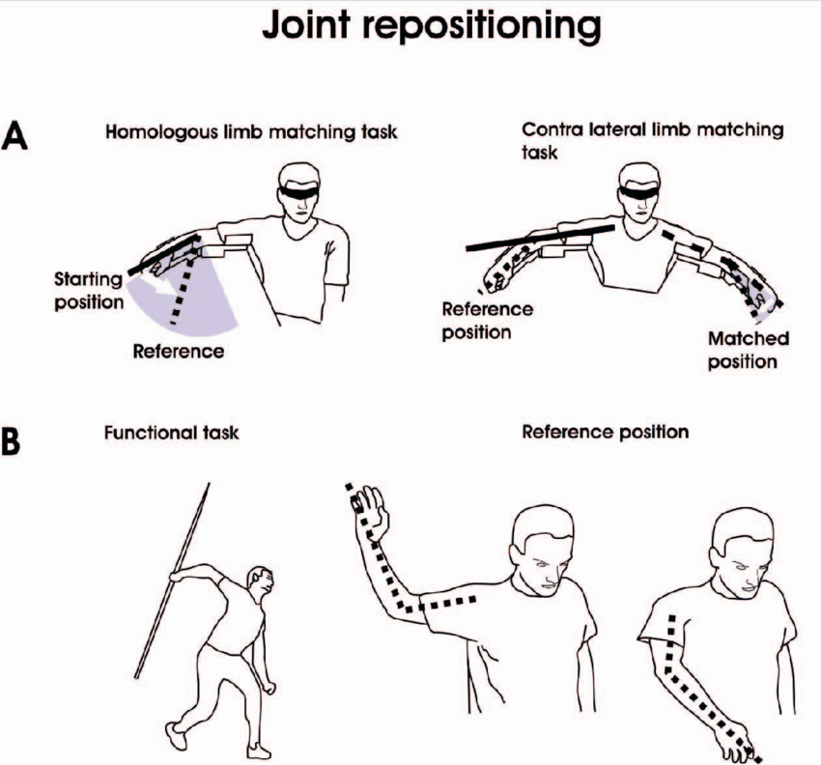

**Support Vector Machine (SVM):** The feature vectors derived from the handcrafted features are used to train an SVM classifier with a radial basis function (RBF) kernel. The SVM model hyperparameters include the kernel (RBF), the regularization parameter (C), and gamma, which defines how far the influence of a single training example reaches. The training process involves splitting the dataset into training and validation sets, training the SVM model on the training set, and evaluating its performance on the validation set using metrics like accuracy, precision, recall and F1-score.

**Ethical Consideration:** Implementing a yoga pose classification system imposes several ethical considerations, particularly concerning data collection, model usage, and potential biases. Gathering photos or videos of yoga poses raises privacy concerns; therefore, participants must obtain authorization and anonymize their data. Bias in the dataset can result in poor model performance for underrepresented groups. Furthermore, the system should not be solely relied upon for guiding yoga practice to avoid potential injuries and misuse for surveillance purposes.